AI ASSISTED CODING
Assignment 6.1
B.Laxmi Spandana
2303A52094
Batch 40
1. Use an AI code completion tool to generate a loop-based
program.
Prompt:
“Generate Python code to print all even numbers between 1 and N
using a loop.”
Code:
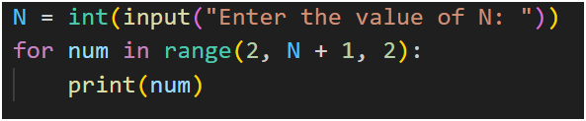
Output:
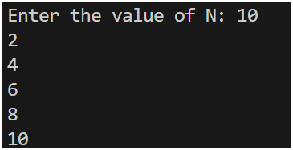
Analysis: The code prompts the user for a value N, then uses a for loop with range(2, N + 1, 2) to iterate through all even numbers from 2 up to N (inclusive). Each even number is printed. This approach is efficient because it skips odd numbers entirely by using a step of 2.

2. Use an AI code completion tool to combine loops and
conditionals.
Prompt:
“Generate Python code to count how many numbers in a list are even
and odd.”
Code:
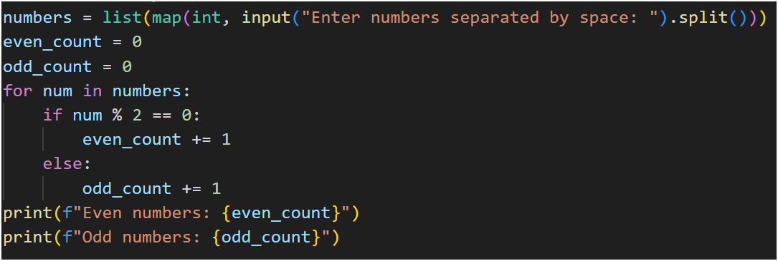
Output:
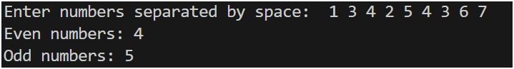
Analysis: The code takes a space-separated list of numbers as input, converts them to integers, and iterates through each number. It uses the modulo operator % to check if a number is even (num % 2 == 0) or odd, incrementing the respective counters. The final counts are printed. This method is straightforward and works for any list of integers.

3. Use an AI tool to complete a Python class that validates user
input.
Prompt:
“Generate a Python class User that validates age and email using
conditional statements.”
Code:
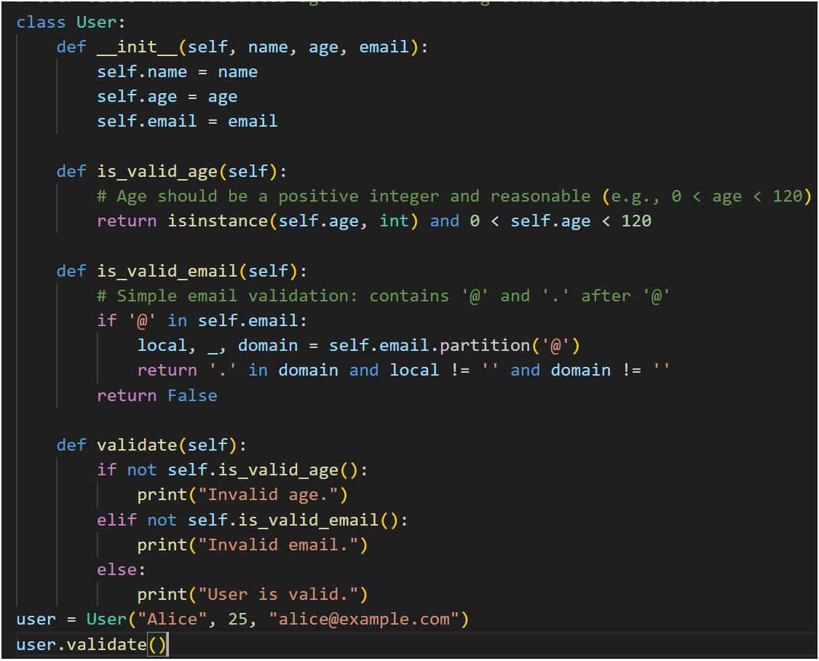

Output:

Analysis: The User class has attributes for name, age, and email. The is_valid_age method checks if age is an integer between 1 and 119. The is_valid_email method checks for the presence of '@' and a '.' in the domain part, ensuring basic email format validity. The validate method prints whether the user is valid based on these checks. This provides simple but effective validation using conditional statements.

4. Use an AI code completion tool to generate a Python class for
managing student details.
Prompt:
“Generate a Python class Student with attributes (name, roll number,
marks) and methods to calculate total and average marks.”
Code:
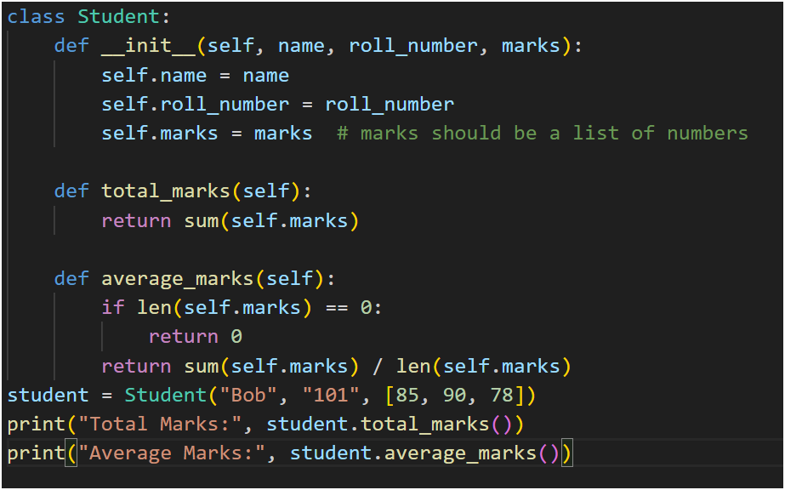

Output:
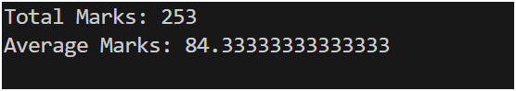
Analysis: The Student class stores name, roll number, and a list of marks. The total_marks method returns the sum of all marks, while average_marks returns the average, handling the case of an empty marks list by returning 0. This design allows easy calculation of total and average marks for any student.

5. Use an AI tool to generate a complete Python program using
classes, loops, and conditionals together.
Prompt:
“Generate a Python program for a simple bank account system using
class, loops, and conditional statements.”
Code: 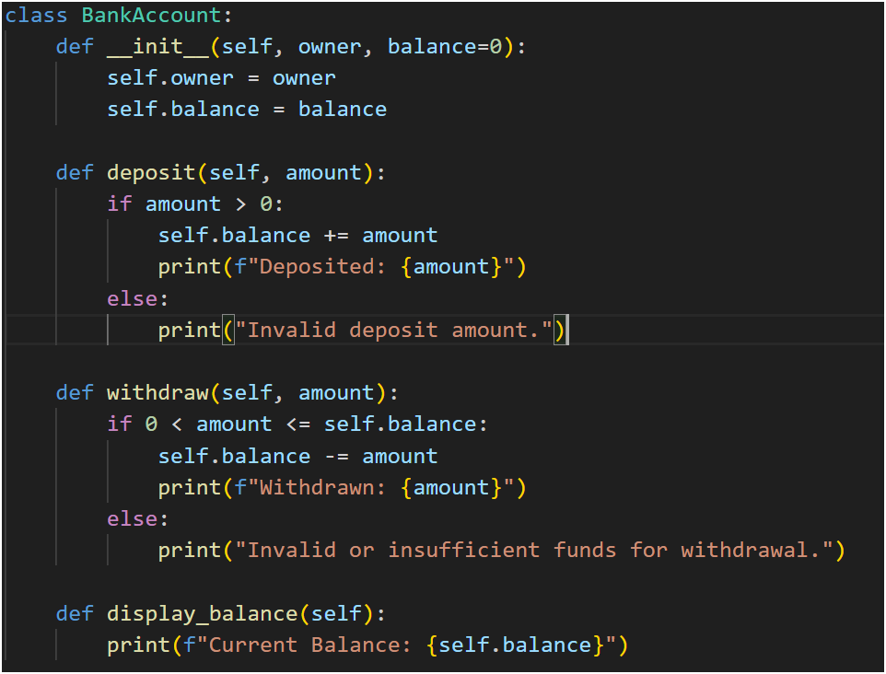
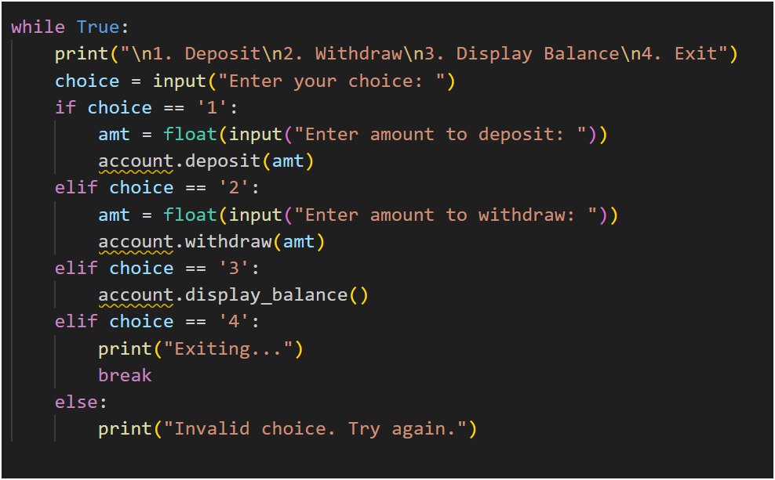

Output:
o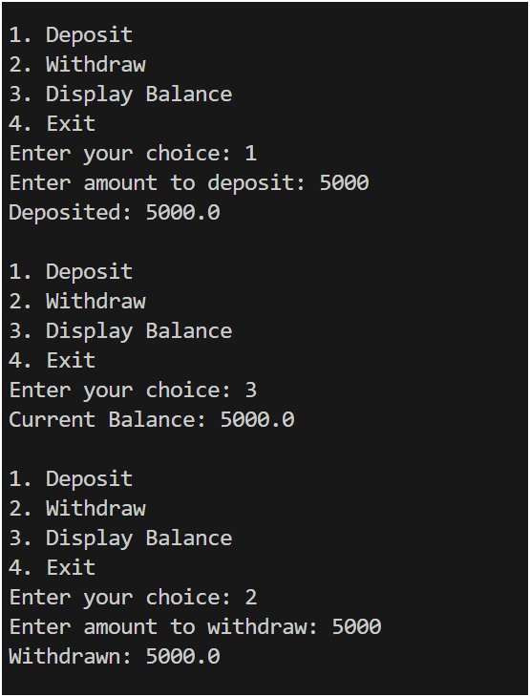
Analysis:
- Class Design: The BankAccount class models a bank account with attributes for the owner's name and balance. It provides methods for depositing, withdrawing, and displaying the balance.
- Deposit Method: Validates that the deposit amount is positive before adding it to the balance. If the amount is invalid, it prints an error message.
- Withdraw Method: Checks that the withdrawal amount is positive and does not exceed the current balance. If the conditions are met, it deducts the amount; otherwise, it prints an error message for invalid or insufficient funds.
- Display Balance: Simply prints the current balance.
- Interactive Loop: Uses a while True loop to repeatedly prompt the user for actions (deposit, withdraw, display balance, exit). User input determines which method is called. The loop continues until the user chooses to exit.
- Conditional Statements: Used throughout to validate user choices and transaction amounts, ensuring the system behaves correctly and securely.

